Customizing Contacts

You can customize your favorite Contacts to display in a different color and different order in you searches as well as to print in your guest lists. To do so, follow these steps:

Step 1
From your “Contacts” screen select the contact you want to customize by double clicking on the name.
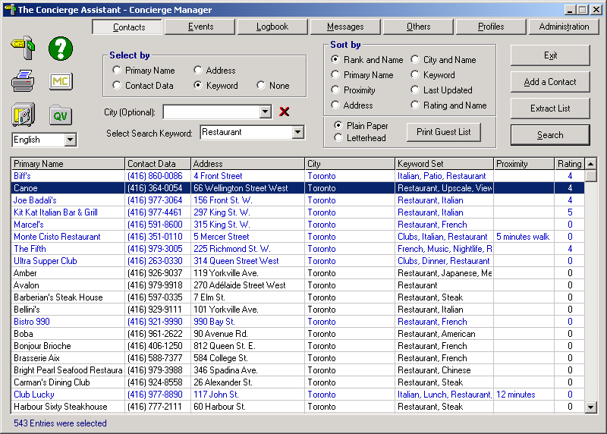

You will see the details for the contact. Select “Color code this contact” and the position on the search list “at the top”. You can rate this contact by selecting how many stars.

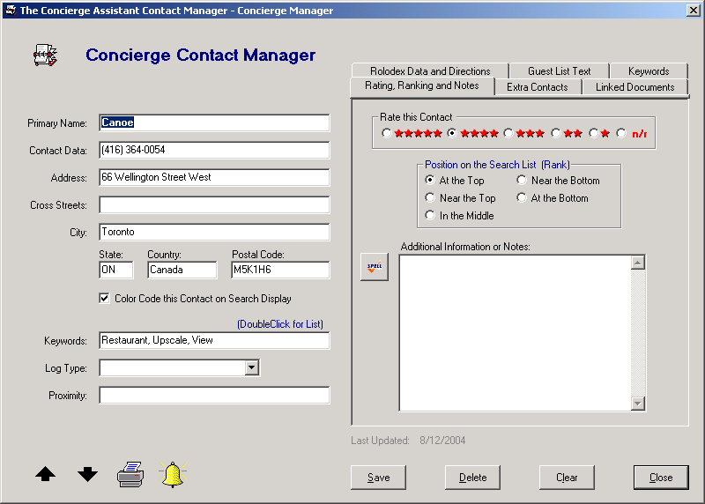
Step 2
Select the “Guest List Text” tab and type the information you would like to print for the guest and check mark “Print on Guest List”

